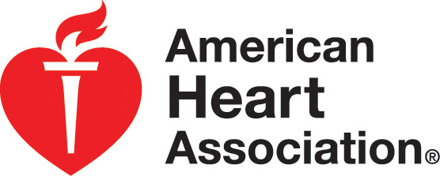
2020 BLS Course Roster
American Heart Association Emergency Cardiovascular Care Programs
WE R CPR 5959 Shallowford Rd Suite 227 Chattanooga, TN 37421
Basic Life Support for Healthcare Providers (BLS HCP)
Ph# 423-553-0400 Fax# 423-648-0530 info@wercpr.com Course Roster Training Center ID# TN20588

Course Information
BLS for Healthcare Providers Lead Instructor ___________________________ID#_____________
□ BLS Classroom Course (Instructor led) Lead Instructor’s Status Renewal Date _______________
□ Renewal BLS Classroom Course (Instructor led)
□ HeartCode® BLS Skills Session Course Location ___________________________________________
Address __________________________________________________
City, State ZIP _____________________________________________

Manikin Decontaminated by:___________________________

Course Start Date/Time _______________ Course End Date/Time _________________ Total Hours of Instruction __________

No. of Cards Issued _________ Student-Manikin Ratio __________ Issue Date of Cards ________________

Assisting Instructors (Attach copy of instructor card for instructors aligned with a TC other than the primary TC)
Name and Instructor ID# Card Exp. Date | Name and Instructor ID# Card Exp. Date
1. | 5.
2. | 6.
3. | 7.
4. | 8.
I verify that this information is accurate and truthful and that it may be confirmed. This course was taught in accordance with AHA guidelines.

___________________________________________ _______________________________________________
Signature of Lead Instructor Date
IN OFFICE USE ONLY
Paid_______________ Enrollware_______________
Issued_____________ Codes Emailed___________
Eval_______________ Received________________
2020 BLS Course Roster
Date _________________ Course ________________Lead Instructor _______________________ Lead Instructor ID#___________
Course Participants
Name and Email  Please PRINT as you wish your name to appear on your card. Please print email address legibly. | Home Address/Telephone | Exam Score/  Remediated Score (if applicable) passing score is 84% or higher | Remediation Date Completed  (if applicable)
1.
2.
3.
4.
5.
6.
7.
8.
9.
10.

