ECC Course Evaluation 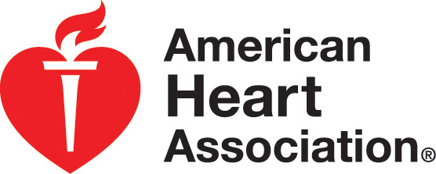
□ PALS □ New Course □ Update Course □ Heartcode Skills Session
Date: Instructors:

Please answer the following questions about your 3. I will respond in an emergency because of the skills
Instructor or Skills Evaluator. I learned in this course.
a. Yes ______
My Instructor or Skills Evaluator: b. No ______
1. Provided instruction and help during my skills c. Not sure ______
practice session
a. Yes ______ 4. I took this course to obtain professional education
b. No ______ credit or continuing education credit.
a. Yes _____
2. Answered all of my questions before my skills test. b. No ______
a. Yes ______
b. No ______ Optional Questions:

3. Was professional and courteous to the students. Have you previously taken this course via another
a. Yes _____ method, such as in a classroom or online?
b. No ______ Which learning method do you prefer and why?

Please answer the following questions about the _____________________________________
course content. _____________________________________
_____________________________________
1. The course learning objectives were clear.
a. Yes _______
b. No ________ Were there any strengths or weaknesses of the
course that you would like to comment on?
- The overall level of difficulty of the course was
a. Too hard _______ _____________________________________
b. Too easy _______ _____________________________________
c. Appropriate _______ _____________________________________

- The content was presented clearly.
a. Yes _______ What would you like to see in the future courses
b. No _______ developed by the AHA?

4. The quality of videos and written materials was ______________________________________
a. Excellent _______ ______________________________________
b. Good __________ ______________________________________
c. Fair ___________
After Completing This Evaluation
Please return this evaluation to your Instructor before you leave the class.

If you have significant problems or concerns with your course, you can send the evaluation to your Instructor’s Training Center:

We R CPR Or Call AHA:
5959 Shallowford Rd. 877-AHA-4CPR
Suite 227
Chattanooga, TN 37421
Fax: 423-648-0530
Ph: 423-553-0400
info@wercpr.com

d. Poor ___________

- The equipment was clean and in good working
condition.
  - Yes _______
  - No ________
Please answer the following questions about your
skill mastery.

1. The course prepared me to successfully pass
the skills session.
- Yes _______
- No ________

2. I am confident that I can use the skills I learned.
a. Yes _______
b. No ________
c. Not sure ________

